### Code: Single Inheritance

class Person {

Name:string

constructor(name:string) {

this.Name= name ;

}

}

class P_name extends Person {

display():void {

console.log("MY name is : "+this.Name) ;

}

}

var obj = new P_name("Vipin Jaiswal");

obj.display()

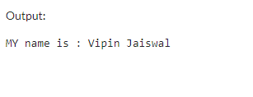

**Code: Multilevel Inheritance**

class Person {

Name:string

constructor(name:string) {

this.Name= name ;

}

}

class P_name extends Person {

display():void {

console.log("MY name is "+this.Name) ;

}

}

class R_name extends Person {

display():void {

console.log("MY name is "+this.Name) ;

}

}

var obj = new P_name("Vipin Jaiswal");

obj.display()

var obj = new R_name("Neha Golatkar");

obj.display()

